MODULE - 5

2. What is the use of E-mail marketing?
Email marketing is a digital marketing strategy that involves sending targeted emails to a group of people to promote products, services, or build relationships. Its main uses include:

1. Direct Communication With Audience:
Email lets you reach your customers directly in their inbox, unlike social media where posts may not be seen due to algorithms.

2. Building Customer Relationships:
You can send newsletters, updates, behind-the-scenes stories, or helpful content to keep your audience engaged and loyal.

3. Promoting Products & Services:
Businesses use emails to announce new products, special offers, discounts, and limited-time deals to boost sales.

4. Lead Nurturing:
Email helps convert interested people (leads) into paying customers by sending follow-up messages, reminders, and educational content.

5. High ROI (Return on Investment):
Email marketing is cost-effective. Studies show that for every $1 spent on email marketing, businesses can earn $30-$40+ in return because sending emails is inexpensive but very effective.

6. Personalised Marketing:
Emails can be customized with the recipient’s name, past purchases, interests, etc., making them more relevant and increasing the chance of conversion.

7. Increasing Website Traffic:
Emails often include links to websites, blogs, landing pages, or online stores to drive traffic.

8. Automation & Scalability:
You can automate welcome emails, birthday emails, abandoned cart emails, etc., so marketing continues even when you’re not actively working.

9. Measurable Results:
You can track open rate, click rate, conversion rate, and other metrics to understand what works and improve future campaigns.

10. Brand Awareness & Trust Building:
Regular email communication helps customers remember your brand and see it as trustworthy and reliable.

3. What goals you can achieve with the help of email marketing?
Email marketing can help businesses achieve multiple marketing, sales, and branding goals. Here are the main goals you can achieve with email marketing:

1. Increase Sales & Revenue:
- Promote products, offers, discounts
- Send abandoned cart reminders to recover lost sales
- Upsell or cross-sell to existing customers

2. Build Strong Customer Relationships:
- Stay connected through newsletters, updates, and personalised messages
- Share helpful content to build trust and loyalty

3. Generate and Nurture Leads:
- Capture leads through sign-up forms and nurture them with automated email sequences
- Convert subscribers into paying customers by educating, reminding, and offering value

4. Increase Website Traffic:
- Link emails to blog posts, landing pages, product pages, or event pages
- Boost traffic to specific campaigns or seasonal promotions

5. Improve Customer Retention:
- Send follow-up emails, thank-you emails, birthday offers, etc.

6. Build Brand Awareness & Authority:
- Regular emails help customers remember your brand
- Keep customers engaged even after a purchase so they return again
- Sharing valuable knowledge positions your brand as an expert in its industry

7. Automate Marketing Tasks:
- Welcome emails, onboarding emails, follow-ups, and re-engagement emails can be automated
- Saves time and keeps communication consistent

8. Collect Customer Feedback:
- Run surveys, reviews, polls, or feedback forms via email
- Helps improve products, service, and customer experience

9. Promote Events or Webinars:
- Send invitations, reminders, and follow-up emails to boost attendance and engagement

10. Increase Customer Lifetime Value (CLV):
- Regular communication encourages repeat purchases
- Loyalty and reward emails help turn one-time buyers into long-term customers

4. Set-up an automation email for www.esellerhub.com abandon cart.
https://app-na2.hubspot.com/email/244299604/details/258373667549/performance
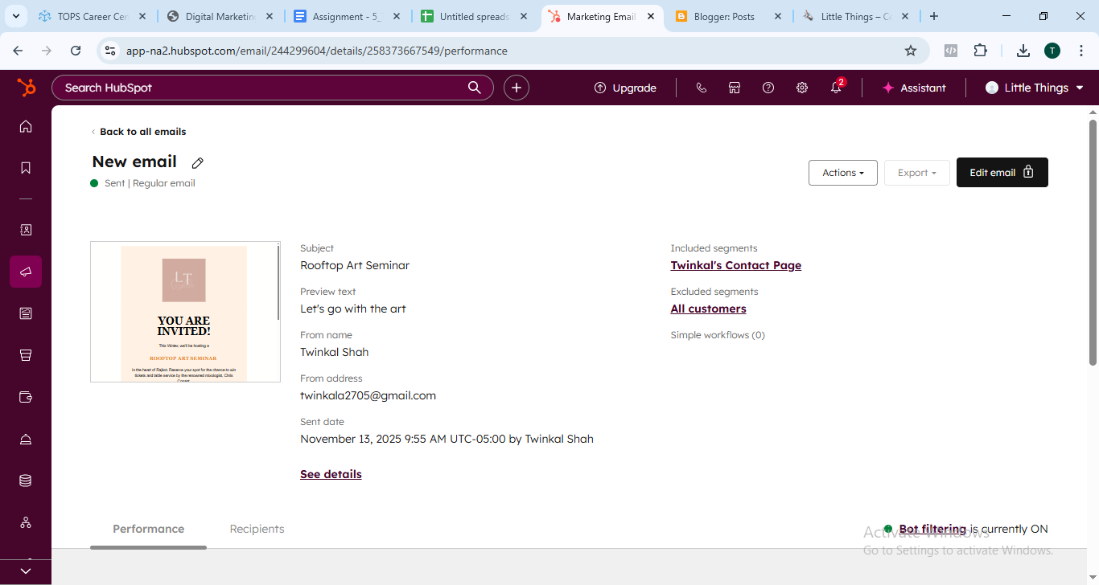

5. What is affiliate Marketing?
Affiliate marketing is a type of performance-based marketing where a business rewards people (called affiliates) for bringing customers or sales through their unique referral link.

How It Works (Simple Explanation):
- A company offers an affiliate program.
- An affiliate signs up and gets a unique tracking link.
- The affiliate promotes the product/service using that link (via social media, website, YouTube, email, etc.).
- When someone clicks the link and makes a purchase, the affiliate earns a commission.

Who Are Involved?
Role | Description
Merchant / Seller | The business selling the product
Affiliate / Publisher | The person promoting the product
Customer | The buyer who clicks and purchases through the affiliate link
Affiliate Network (optional) | The platform that tracks clicks, sales, commissions (ex: Amazon Associates, ClickBank, ShareASale)

How Affiliates Earn Money:
- Per Sale (most common): Earn % of the sale price
- Per Click (PPC): Earn when someone clicks the link
- Per Lead (PPL): Earn when someone signs up or fills a form
Benefits of Affiliate Marketing:
For the business:
- Pays only for results (low risk)
- Gets more promotion and customers without doing all marketing themselves
For the affiliate:
- Can earn passive income
- No need to create a product or handle shipping/support
- Can work from anywhere (blog, social media, YouTube, etc.)

Examples of Affiliate Marketing:
- You share an Amazon product link → someone buys → you get a commission
- A YouTuber shares a discount code for a brand → earns money for every use
- A blogger writes “Top 10 Laptops of 2025” and earns if readers buy through links

6. List some famous websites available for affiliate marketing.
Here are some of the well-known affiliate marketing networks and platforms where you can join as an affiliate (or a merchant) and start earning/partnering. Each has slightly different features, strengths and merchant types, so you’ll want to pick one that fits your niche.

Top Affiliate Platforms:
- Amazon Associates
One of the most recognised affiliate programmes. You can promote almost any product sold on Amazon and earn a commission.
  - Good for beginners since Amazon is trusted and has huge product range.
  - Commission rates tend to be lower than niche high-ticket networks, so volume and relevance matter.
  - Especially useful if you already have a blog, YouTube channel or social media with product-recommendation content.
- ClickBank
A marketplace oriented more toward digital products (courses, e-books, software) though also physical sometimes.
  - High commission potential in many cases (because digital goods often allow larger margins).
  - Ideal if you’re comfortable promoting online services or info-products rather than just physical goods.
- Awin
A global affiliate network with many merchants across verticals (retail, travel, finance etc.).
  - Good for affiliates wanting a large selection of merchants and cross-border options.
  - Requires more effort to pick the right merchant + campaign.
- CJ Affiliate (formerly Commission Junction)
One of the more established networks with strong infrastructure.
  - More advanced tracking, good for bigger sites or those who want scale and more control.
- Rakuten Advertising
Another major affiliate network with global reach and many brand-affiliate partnerships.
  - Good for affiliates looking at higher-quality/brand-side offers, somewhat less mass-market than Amazon in some verticals.
- ShareASale
A large network especially popular among smaller-to-mid sized merchants and affiliates.
  - Could be a great pick if you affiliate-market from a blog or niche website and want variety beyond the big brands.

Quick Summary Comparison:
Platform | Strengths | When to pick it
Amazon Associates | Massive product range, high trust | You have broad-audience or product-review content
ClickBank | High commissions with digital goods | You promote courses, software, info-products
Awin | Global merchants, many verticals | You have international traffic or niche verticals
CJ Affiliate | Advanced features & large brands | You run a large site or  expect scale
Rakuten Advertising | Strong brand offers, global reach | You prefer premium brands over volume
ShareASale | Many merchant options, good for niche | You run a blog/website in a specific niche
7. Which are the platforms you can use for affiliate marketing?
You can do affiliate marketing in two main ways:

1. Affiliate Networks (Marketplaces with many brands):
These platforms connect you with hundreds or thousands of companies offering affiliate programs.
Platform | Best For | Highlights
Amazon Associates | Beginners, product reviews | Huge product range, global trust
ClickBank | Digital products, courses, ebooks | High commission rates (up to 70%)
CJ Affiliate (Commission Junction) | Big brands, advanced marketers | Strong tracking, many premium brands
ShareASale | Bloggers, niche sites | 21k+ merchants, easy to join
Awin | Global affiliates | Many categories, worldwide payouts
Rakuten Advertising | Premium global brands | Trusted network, long-term partnerships
Impact | Influencers, content creators | Good dashboard, big brands
Digistore24 | Digital + physical products | Fast sign-up, high commissions
PartnerStack | SaaS / software referrals | Used by tech companies like Canva, Notion

2. Direct Brand Affiliate Programs:
Some companies run their own affiliate program (not through a network).
Examples:
- Shopify Affiliate Program
- Canva Affiliate Program
- Hostinger / Bluehost (Web hosting)
- Fiverr Affiliate Program
- Coursera / Udemy
- Nike / Adidas / Apple (in some regions)
These are good when you want to promote one strong brand instead of many.

3. Affiliate Platforms Popular in India:
If you want local brands + Indian payouts:
Platform | Works With
Flipkart Affiliate | Flipkart products
Amazon India Associates | Amazon.in marketplace
vCommission | Brands like Myntra, Swiggy, Mamaearth
Cuelinks | 4000+ Indian retailers, auto-affiliate links
Admitad | Global + Indian brands (Ajio, TataCliq, etc.)
EarnKaro | Owned by Ratan Tata–backed company

4. Where You Can Promote Affiliate Links:
You can use affiliate links on:
-Blog / Website
-YouTube videos
-Instagram / Facebook / Pinterest
-Email newsletters
-WhatsApp groups (if allowed)
-Telegram channels
-Twitter / LinkedIn posts
-Review or coupon websites

